**BASAVARAJESWARI GROUP OF INSTITUTIONS**

**Ballari Institute of Technology & Management**

**AUTONOMOUS INSTITUTE UNDER VISVESVARAYA TECHNOLOGICAL UNIVERSITYJNANA SANGAMA, BELAGAVI 590018**

**INTERNSHIP**

**Report On**

# INVENTORY MANAGEMENT SYSTEM

Submitted in partial fulfilment of the requirements for the award of degree of

**Bachelor of Engineering**

**In**

**COMPUTER SCIENCE AND ENGINEERING**

## Submitted by

**SHAIK NABI SAB**

**3BR23CS145**

## Internship Carried Out By

**EZ TRAININGS & TECHNOLOGIES PVT.LTD**

**Internal Guide External Guide**

**Ajay**

**Technical Trainer**

### BALLARI INSTITUTE OF TECHNOLOGY & MANAGEMENT

NACC Accredited Institution*

**(Recognized by Govt. of Karnataka, approved by AICTE, New Delhi & Affiliated to Visvesvaraya Technological University, Belagavi)**

**"Jnana Gangotri" Campus, No.873/2, Ballari- Hospet Road, Allipur, Ballar1-583 104 (Karnataka) (India) Ph: 08392 – 237100 / 237190, Fax: 08392 – 237197**

**2024-2025**

**BASAVARAJESWARI GROUP OF INSTITUTIONS**

## BALLARI INSTITUTE OF TECHNOLOGY & MANAGEMENT

**Autonomous institute under VISVESVARAYA TECHNOLOGICAL UNIVERSITYJNANA SANGAMA,**

**BELAGAVI 590018**

NACC Accredited Institution*

**(Recognized by Govt. of Karnataka, approved by AICTE, New Delhi & Affiliated to**

**Visvesvaraya Technological University, Belagavi)**

### "JnanaGangotri"Campus,No.873/2,Ballari-HospetRoad,Allipur,

**Ballar1-583 104 (Karnataka)(India)**

**Ph: 08392 – 237100 / 237190, Fax: 08392 –237197**

**DEPARTMENT OF COMPUTER SCIENCE AND ENGINEERING**

# CERTIFICATE

This is to certify that the Internship entitled **“INVENTORY MANAGEMENT SYSTEM”** has been successfully completed by **SHAIK NABI SAB** bearing USN **3BR23CS145** a bonafide student of Ballari Institute of Technology and Management,

Ballari. For the partial fulfilment of the requirements for the **Bachelor’s Degree in Computer**

**Science and Engineering** of the VISVESVARAYA TECHNOLOGICAL UNIVERSITY,

Belagavi during the academic year 2023-2024.

**Signature of Internship Signature of HOD**

**Co-ordinator**

**R N KULKARNI**

**Prof. and HOD(CSE)**

**DECLARATION**

I, **SHAIK NABI SAB,** second year student of Computer Science and Engineering, Ballari

Institute of Technology, Ballari, declare that Internship entitled **“INVENTORY MANAGEMENT SYSTEM”** is a part of Internship Training successfully carried out by **EZ TECHNOLOGIES & TRAININGS PVT.LTD** at “**BITM,BALLARI”.** This report is submitted in partial fulfilment of the requirements for the award of the degree, Bachelor of Engineering in Computer Science and Engineering of the Visvesvaraya Technological University, Belagavi.

**Date : Signature of the Student**

**Place :**

**ACKNOWLEDGEMENT**

The satisfactions that a company the successful completion of my internship on “INVENTORY

MANAGEMENT SYSTEM” would be incomplete without the mention of people who made it possible, whose noble gesture, affection, guidance, encouragement and support crowned my efforts with success. It is my privilege to express my gratitude and respect to all those who inspired me in the completion of my internship.

I am grateful to our respective coordinator for his noble gesture, support co-ordination and valuable suggestions given to me in the completion of Internship.

I also thank **R N Kulkarni,** H.O.D. Department of **Computer science and engineering** for extending all his valuable support and encouragement.

**Day to Day Activity:-**

|  |  |  |
| --- | --- | --- |
| **Days** | **Topic** | **Topic** |
| **Day 01** | **Introduction to python(data types, variable)** | **Keywords, comments , indentations, operators** |
| **Day 02** | **Conditional statements, looping** | **Problem solving using loops and pattern programs** |
| **Day 03** | **Functions, string operations, Problem solving** | **Recursion, class and object, constructor** |
| **Day 04** | **List, Tuple** | **Set, Dictionary (Problem solving using list, tuple)** |
| **Day 05** | **OOPS(Inheritance, Polymorphism)** | **Encapsulation, Abstraction** |
| **Day 06** | **Exceptional handling, File handling** | **Problem solving** |
| **Day 07** | **Problem solving (15 ques)** | **Problem solving (10 ques)** |
| **Day 08** | **Revision and scenarios**  **Problem solving** | **Revision and scenarios**  **Problem solving** |
| **Day 09** | **Modules and packages** | **OOPS revision** |
| **Day 10** | **Introduction to D.S, Big O (time complexity, class pointers)** | **Introduction to linked list (get, self, insert, remove)** |
| **Day 11** | **Linked list, stack (Push, pop, is full, is empty, peak, display)** | **Queue (constructor, enqueue, dequeue), priority queue** |
| **Day 12** | **Bubble sort, selection sort, insertion sort** | **Merge sort and task in sorting** |
| **Day 13** | **Recursion, Quick sort (5 problems)** | **Linear search and problem solving(Assessment)** |
| **Day 14** | **Binary search, Introduction to Trees, Tree traversal** | **Traversal, insertion searching(BFS, DFS)** |
| **Day 15** | **Introduction to graph (BFS, DFS), introduction to graph algorithm** | **Project team separation and discussing the problem statement with each team** |
| **Day 16** | **Project implementation** | **Project implementation and problem solving in reinprep portal** |
| **Day 17** | **Project implementation**  **Phase-01** |  |

**INVENTORY MANAGEMENT SYSTEM**

**Problem:-**

* **The CRUD(create , read , update, delete)product inventory.**
* **Automatic alerts for low stocks.**
* **Reporting capabilities for sales.**
* **Generation of sales reports based on time period**

**The CRUD (Create, Read, Update, Delete) inventory system is a foundational approach to managing inventory, ensuring that businesses can keep track of their products, maintain sufficient stock levels, and respond quickly to customer demand. To ensure smooth operations, the system also needs to**

**\*Alert for low stock levels**

**\*Generate sales reports**

**\*To provide insights into business performance.**

**Shaik Nabi Sab :3BR23CS145**

**Vanitha. D : 3BR23CS180**

**V. Lakshmi Geetha :3BR23CS179**

**Y.G. Sanjana : 3BR23CS188**

**Shravan Kumar. V :3BR23CS152**

**### Pseudocode for Inventory System:**

**START**

**1. CLASS InventoryItem:**

**- Method: __init__(name, quantity, price)**

**- Initialize item with name, quantity, and price.**

**2. CLASS InventorySystem:**

**- Method: __init__()**

**- Initialize an empty list called inventory.**

**- Method: add_item(item)**

**- Append the given item to the inventory list.**

**- Method: update_item(name, quantity, price)**

**- FOR each item in inventory:**

**- IF item.name == name:**

**- Update item.quantity and item.price with given values.**

**- Method: delete_item(name)**

**- Remove items from inventory where item.name == name.**

**- Method: check_low_stock(limit)**

**- FOR each item in inventory:**

**- IF item.quantity < limit:**

**- Add item to the low_stock_items list.**

**- RETURN low_stock_items.**

**- Method: generate_sales_report(start_date, end_date)**

**- Calculate total sales by summing item.price * item.quantity for all items in inventory.**

**- RETURN total_sales.**

**3. MAIN FUNCTION:**

**- Initialize an InventorySystem object.**

**- Prompt user to enter the number of items to add (n).**

**- FOR i = 1 to n:**

**- Prompt user to enter item name, quantity, and price.**

**- Create a new InventoryItem object with the provided details.**

**- Add the item to the inventory system using add_item().**

**- Prompt user to enter the name of the item to delete.**

**- Call delete_item() to delete the item from the inventory.**

**- IF the item does not exist:**

**- Print "No item to delete."**

**- ELSE:**

**- Print "The item deleted is <name>."**

**- Prompt user to enter the name of the item to update.**

**- Prompt user to enter the new quantity and price.**

**- Call update_item() to update the specified item.**

**- Call check_low_stock(10) to get a list of items with low stock.**

**- Print the names of items with low stock.**

**- Call generate_sales_report(start_date, end_date) to calculate total sales for the specified period.**

**- Print the total sales for the period.**

**END**

Output:-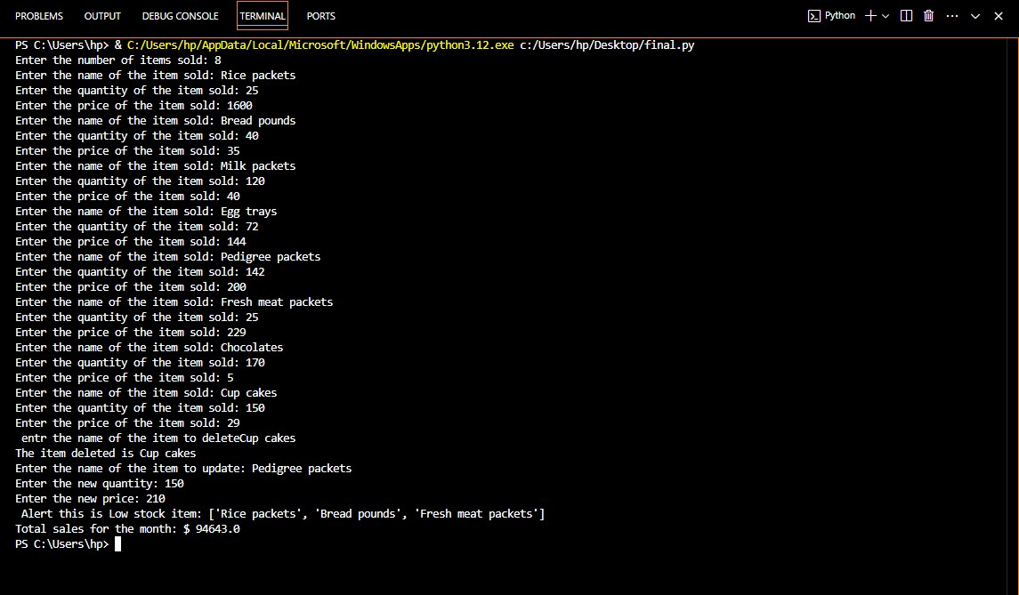

**Conclusion:-**

**The project successfully implements an inventory management system using Python. The program allows for the addition, update, and deletion of inventory items, checks for low stock alerts, and generates sales reports for a specific time period. This project showcases the practical application of programming concepts in a real-world scenario, aiding in efficient inventory control and sales analysis.**

**Table of Contents**

|  |  |  |
| --- | --- | --- |
| **Chapter No.** | **Chapter Name** | **Page No.** |
| **1** | **Company Profile** | **01-04** |
| **2** | **Day to day activity (student dairy extend)** | **05-06** |
| **3** | **Introduction of the project** | **07** |
| **4** | **Description** | **07** |
| **5** | **Algorithm** | **08-09** |
| **6** | **Output** | **10** |
| **7** | **Conclusion** | **10** |